30 DAY SQUAT CHALLENGE!!!!

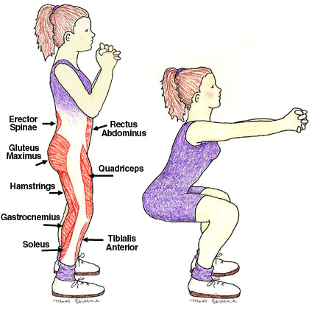

|  |  |  |  |  |  |  |
| --- | --- | --- | --- | --- | --- | --- |
| SUNDAY | MONDAY | **TUESDAY** | **WEDNESDAY** | **THURSDAY** | **FRIDAY** | **SATURDAY** |
|  | DAY 1  50 SQUATS | DAY 2  55 SQUATS | DAY 3  60 SQUATS | DAY 4  REST | DAY 5  70 SQUATS | DAY 6  75 SQUATS |
| DAY 7  80 SQUATS | DAY 8  REST | DAY 9  100 SQUATS | DAY 10  105 SQUATS | DAY 11  110 SQUATS | DAY 12  REST | DAY 13  130 SQUATS |
| DAY 14  135 SQUATS | DAY 15  140 SQUATS | DAY 16  REST | DAY 17  150 SQUATS | DAY 18  155 SQUATS | DAY 19  160 SQUATS | DAY 20  REST |
| DAY 21  180 SQUATS | DAY 22  185 SQUATS | DAY 23  190 SQUATS | DAY 24  REST | DAY 25  220 SQUATS | DAY 26  225 SQUATS | DAY 27  230 SQUATS |
| DAY 28  REST | DAY 29  240 SQUATS | DAY 30  250 SQUATS | CONGRATS YOU  DID IT!!! | LOOK FORWARD  TO THE NEXT  CHALLENGE!!! |  |  |